Summer 2 week 2
Communication and Language/Literacy/Phonics
We have been focussing on a Think Equal text- ‘Sizwe’s Smile’ and ‘The Proudest Blue’ by Ibtihaj Muhammad. We have also been reading about sunflowers and their lifecycle.

https://www.youtube.com/watch?v=cfmc_llybcU

Physical Development
We have been practising ball catching skills and throwing skills. We have been practising bouncy hopper skills. We have been practising our balance skills in P.E.
We will continue to practise dance routines in the hall, threading and Dough Disco. We are building up our fine motor control.

Maths
In maths we have been learning to ‘puzzle’
These are the steps we have been using in school. Please use these activities to consolidate learning at home.
Complete shape-match puzzles
Match objects to pictures
Look for collections of large and small amounts
Explore objects and small world from different positions
Complete simple jigsaws
Match objects to shadows
Make simple routes in small world with lines and curves
Other Learning
We looked at the lifecycle of a sunflower and made a sculpture of a sunflower seed using clay, white paint and black fine paintbrush to add detail. We looked at Ai Weiwei’s installation of clay sunflower seeds in the Tate.

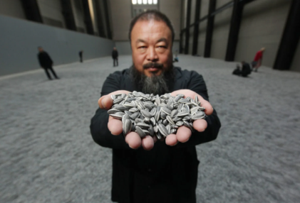
Homework
Please continue to read with your child every day for 5 minutes. Please practise the phonics skill of blending with your child. An example of this is ‘Please put on your c-oa-t.’
Note to parents -phonemes are sounds not letter names.
For an explanation of phonemes used and ‘pure sounds’ is below.

https://www.youtube.com/watch?v=UCI2mu7URBc

Thank you for your continued support
The Nursery Team

