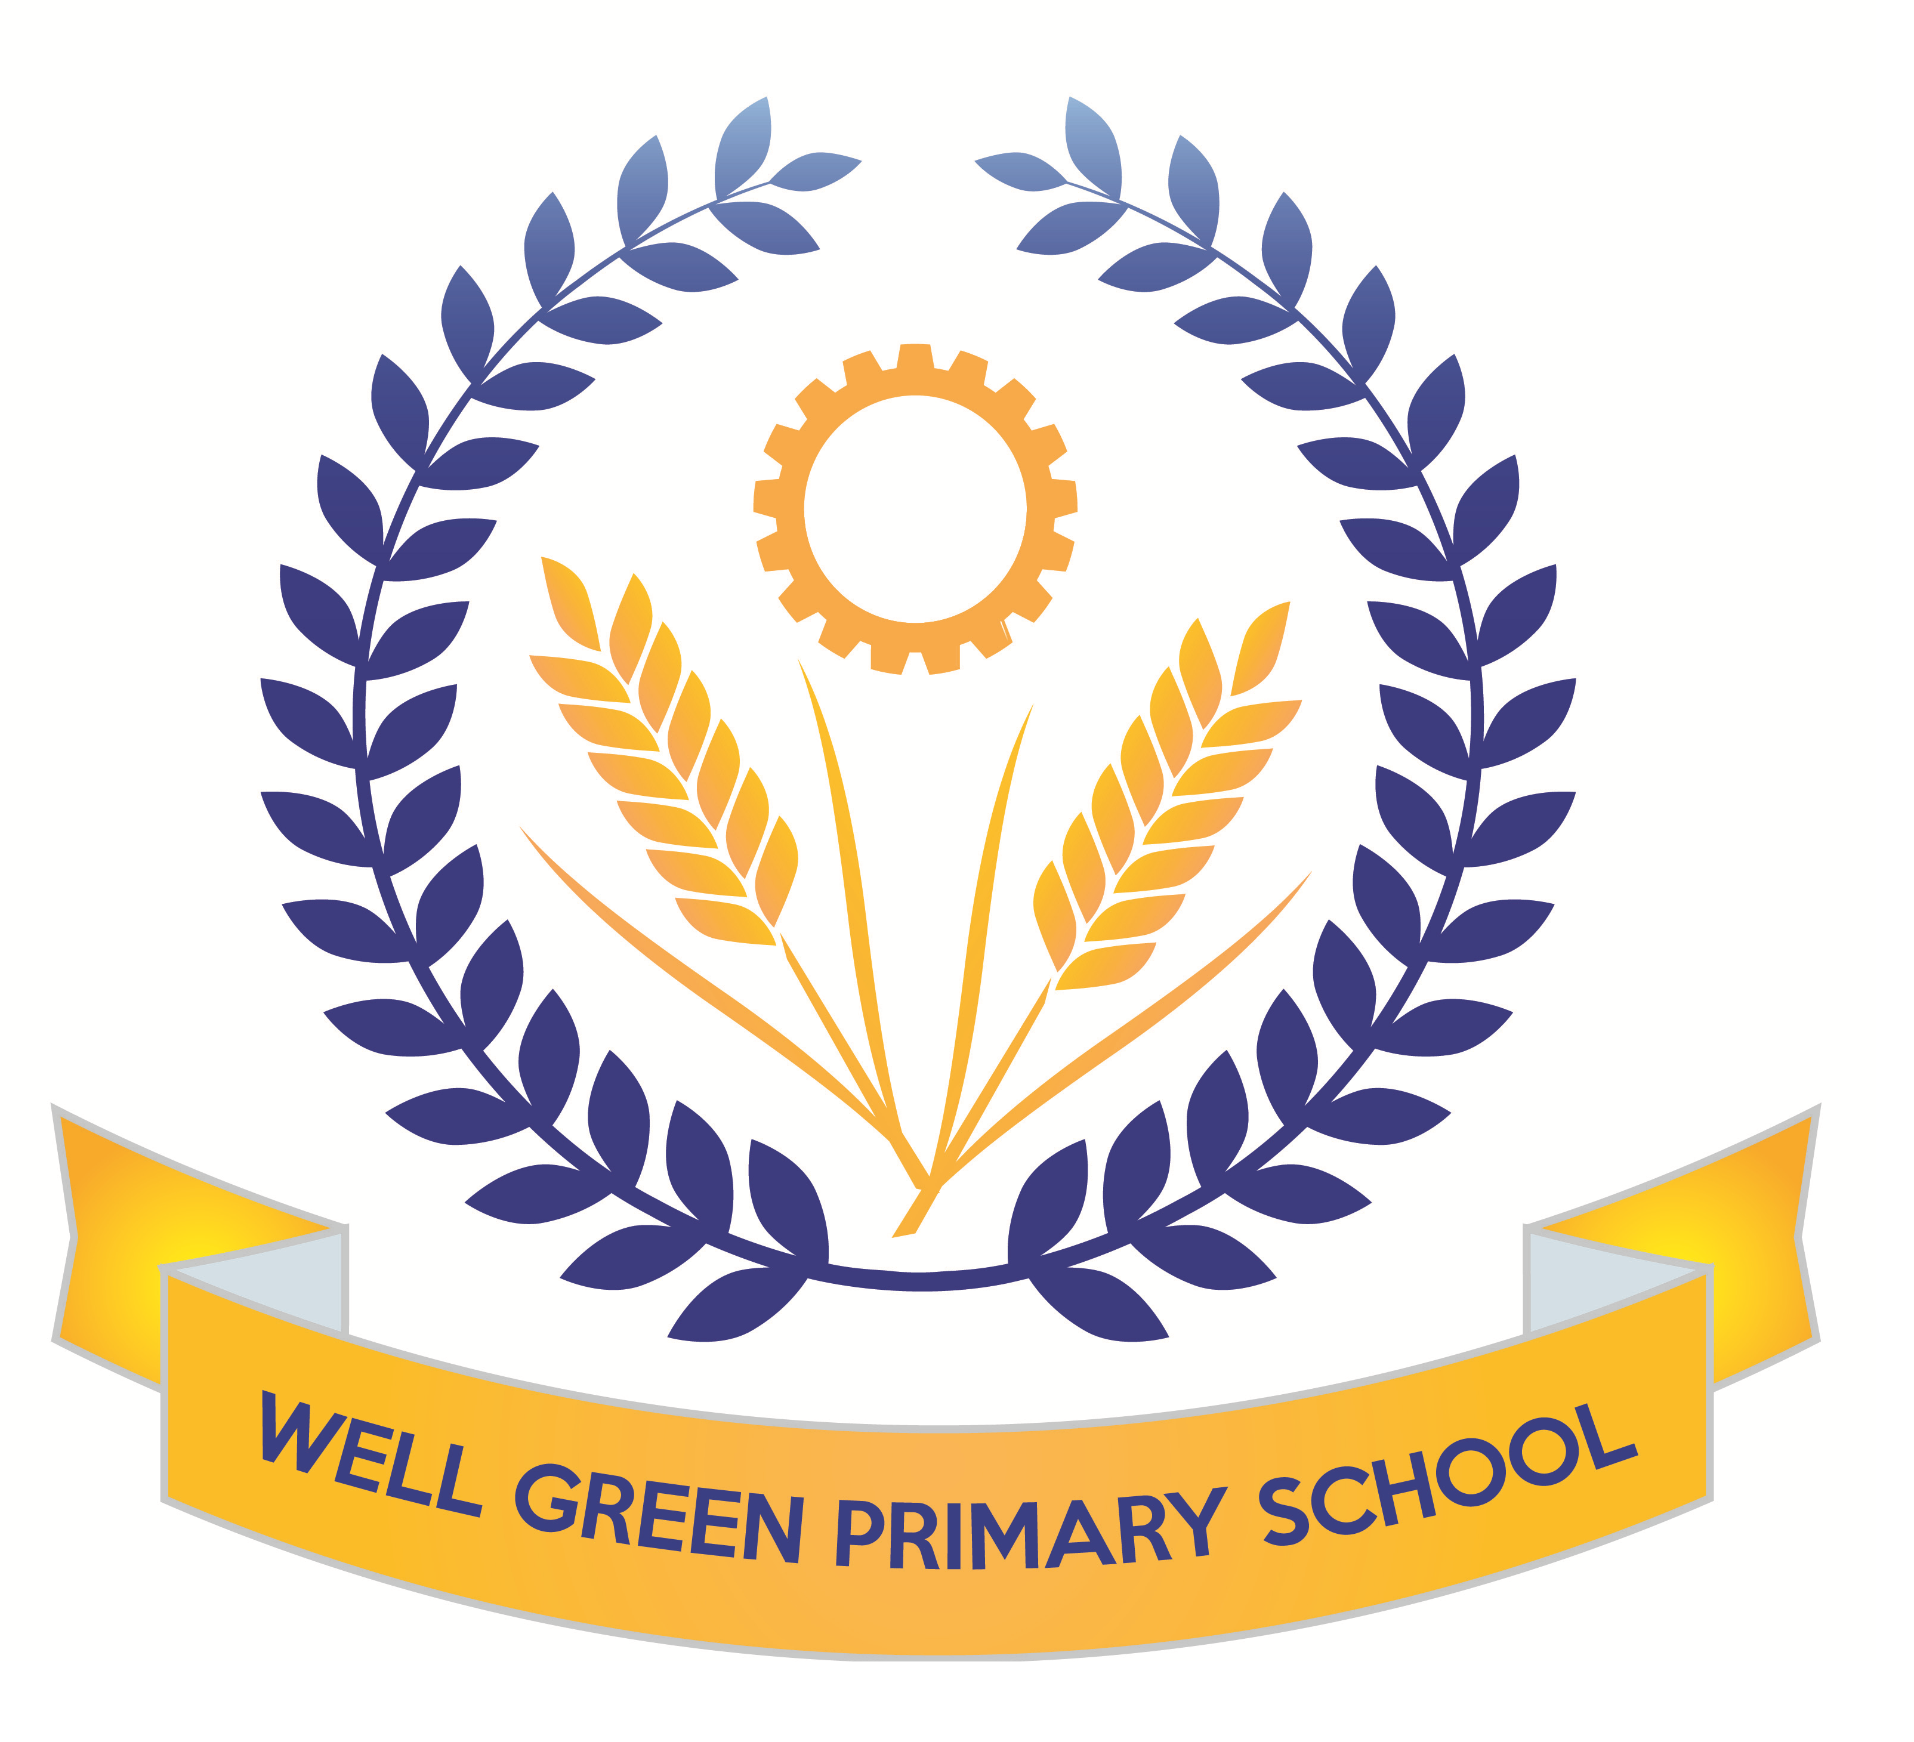

In Summer 1, the curriculum coverage and targets for Year Six will be:
English | Texts: descriptive writing of a favourite meal, non-fiction text regarding Michael’s disappearance linked to Kensuke’s Kingdom, and non-fiction information text about wolves from North America.  Reading- comprehension skills and revision of question types for tests (fact/ opinion and true/ false) and 3 mark answers with PEE (point, evidence and explain)  Grammatical terminology, syntax and punctuation rules and their application in preparation for the SPAG test.  Spelling: consolidation of spelling rules, using known root words, prefixes and suffixes.
English targets | - To revise all key concepts of SPAG covered and know the key terminology  - To be able to identify different types of pronouns- relative, personal and possessive  - To be able to spell words from the key words list from Y3/4 and Y5/6 (as many as possible)  - To recognise the past perfect and past progressive tenses and be able to use these  - To be able to identify words as conjunctions or prepositions in sentences  - To be able to use a full range of punctuation in writing and apply key spellings and use neat handwriting
Maths | Shape and geometry for properties of 2D/3D shapes, including angles, reflections and translations.  Statistics and data handling - extracting information from tables, pie charts, bar charts and line graphs to solve problems.  Revision of all areas and reasoning skills  Revision of formal written and mental calculation methods for +, -, x & ÷.
Maths targets | - To revise all key concepts covered in Maths  - To develop calculations skills using written arithmetic, including to calculate written division with a formal method with decimal and fraction remainders  - To recognise angles around a point, on a straight line or that are vertically opposite and find missing angles.  - To reflect and translate shapes  - To be able to solve multi-step problems using reasoning  - To be able to identify different parts of a circle  - To be able to use line graphs and conversion graphs to solve problems
Science | We will cover the topic ‘evolution and inheritance’ and begin to study the theory of Charles Darwin and how species have evolved, including a focus on dog breeds and inherited characteristics.
Computing | This half term we are focusing on ‘Text Adventures’. We will plan and create a story-based adventure in 2Create a Story. We will contrast a map-based game with a sequential story-based game. Also, we will learn to create our own text-based adventure based upon a map.
Geography | We will begin our work in Geography based on North America and the USA.  We will be mapping the states and countries and learning about the geographical significance of this part of the world. We will study climate regions, tourist attractions, agriculture and industry patterns and the landscapes.
DT | This half term, the children will continue to develop their use of science and electrical circuits and design and make an electrical item such as a wire hoop game.
Music | Performance songs-singing in two parts and accompaniments  Beginning to learn songs for the performance and develop music to accompany.
P.E. | The children will also develop their cricket skills using the new equipment in school to practise ball control, passing techniques, tactics and matches.  Tennis- weekly sessions to develop skills for tennis and work on matches and develop scoring systems.
R.E. | Beliefs and Practices  Islam  The life and teachings of the Prophet Muhammad linked to work in history on Ancient Islamic Civilisations.
P.S.H.E. & Citizenship | We will have a focus on Relationships:  -Knowing myself, understanding & managing my feelings, understanding the feelings of others, developing social skills and making choices  Safe & Healthy Relationships:  - Do gender stereotypes have an impact on our behaviour?  Health & Fitness: We will have a healthy minds and healthy bodies focus week with discussion of Safety with drugs/Alcohol/smoking. Food & Diet and healthy minds. Our British Values focus for this half term is tolerance.

Weekly homework will be handed out on Friday, to be returned to school by the following Wednesday.

Spelling Test: Friday Mental Arithmetic Test: Thursday Guided Reading: Monday

P.E.: Tuesday (cricket), Friday (tennis)

Please can you also ensure your child has the correct equipment required for school: A blue cartridge pen with spare refills, pencil, ruler, glue stick and eraser. They also require a named water bottle.

Key Dates for the Summer Term:
- Friday 6th May: Eid assembly
- Monday 9th May: beginning of SATs week
- Thursday 12th May: Robin Wood Parents meeting
- Monday 16th May: school photographs
- Tuesday 17th May: musical morning
- Friday 20th May: PTA film night
- Monday 23rd May: SRE week
- Friday 27th May: Jubilee tea party
- Wednesday 15th June: Robin Wood residential trip
- Friday 24th June: Mock Trial with Magistrates in Manchester
- Friday 1st July: Sports day
- Tuesday 12th July: Year 6 performance
- Wednesday 13th July: Year 6 performance (6PM)
- Thursday 14th July: Bastille Day
- Tuesday 19th July: Thank you breakfast, Y6 leaver’s disco (6pm-7:30pm)
- Wednesday 20th July: Y6 Leaver’s assembly (9:15am)
- Wednesday 21st July: Leaver’s Assembly (9.15am), take away (lunchtime)
- Thursday 21st July: Final day of term (shirt signing and toys)

Thank you for your continued support and co-operation.
Mrs Santer and Mrs Oldham
The key stage 2 tests are timetabled from Monday 9th May to Thursday 12th May 2022.
There is a timetable below showing the details of the tests being held in school for the week commencing 9th May for the Y6 children.
Please ensure children arrive in school promptly this week and have a good night’s sleep and good breakfast to enable them to achieve their very best during these external exams.
Results of the tests will be published in July and will be reported to parents in the end-of-year reports.
Monday 9th May 2022 | English grammar, punctuation and spelling Paper 1:  questions  45 mins
Monday 9th May 2022 | English grammar, punctuation and spelling Paper 2:  spelling  15 mins
Tuesday 10th May 2022 | English reading  1 hour
Wednesday 11th May 2022 | Mathematics Paper 1: arithmetic  30 mins
Wednesday 11th May 2022 | Mathematics Paper 2: reasoning  40 mins
Thursday 12th May 2022 | Mathematics Paper 3: reasoning  40 mins
Friday 13th May 2022 | Writing assessment

