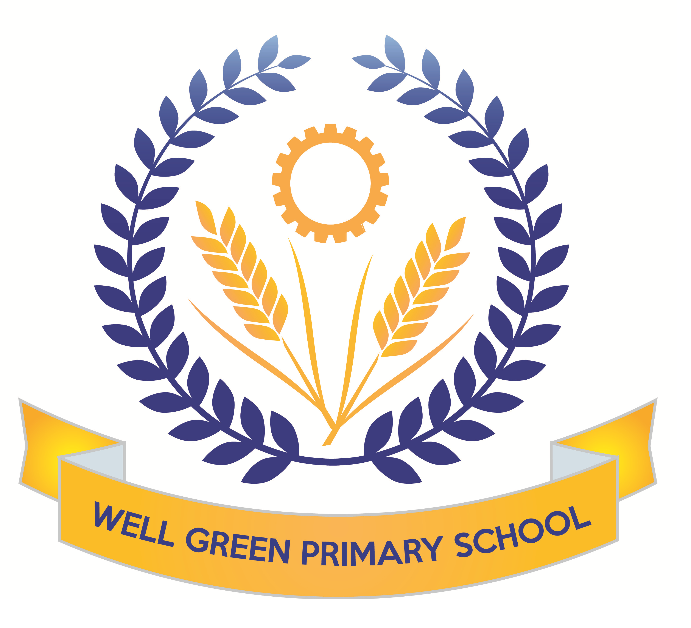

In Summer 1, the curriculum coverage and targets for Year Six will be:
English | Texts: Haiku poems and letters in a bottle linked to Kensuke’s Kingdom, descriptive writing about favourite meal and non-fiction information text about wolves from North America.  Reading- comprehension skills and revision of question types for tests (fact/ opinion and true/ false) and 3 mark answers with PEE (point, evidence and explain)  Grammatical terminology, syntax and punctuation rules and their application in preparation for the SPAG test.  Spelling: consolidation of spelling rules, using known root words, prefixes and suffixes.
English targets | - To revise all key concepts of SPAG covered and know the key terminology  - To be able to identify different types of pronouns- relative, personal and possessive  - To be able to spell words from the key words list from Y3/4 and Y5/6 (as many as possible)  - To recognise the past perfect and past progressive tenses and be able to use these  - To be able to identify words as conjunctions or prepositions in sentences  - To be able to use a full range of punctuation in writing and apply key spellings and use neat handwriting
Maths | Shape and geometry for properties of 2D/3D shapes, including angles, reflections and translations.  Statistics and data handling - extracting information from tables, pie charts, bar charts and line graphs to solve problems.  Revision of all areas and reasoning skills  Revision of formal written and mental calculation methods for +, -, x & ÷.
Maths targets | - To revise all key concepts covered in Maths  - To develop calculations skills using written arithmetic, including to calculate written division with a formal method with decimal and fraction remainders  - To recognise angles around a point, on a straight line or that are vertically opposite and find missing angles.  - To reflect and translate shapes  - To be able to solve multi-step problems using reasoning  - To be able to identify different parts of a circle  - To be able to use line graphs and conversion graphs to solve problems
Science | Continuation of work on electricity:  We will construct circuits to make buzzers and switches operate to link with our work in DT to create a working buzzer game.  We will also begin to cover the topic ‘evolution and inheritance’ and begin to study the theory of Charles Darwin and how species have evolved, including a focus on dog breeds and inherited characteristics.
Computing | This half term we are focusing on ‘Text Adventures’. We will plan and create a story-based adventure in 2Create a Story. We will contrast a map-based game with a sequential story-based game. Also, we will learn to create our own text-based adventure based upon a map.
History | We will be learning about the early Islamic Civilisation in Baghdad in 900 AD. We will be finding out about the Prophet Mohammed and the influence and rise of Islam. We will learn about the significance and importance of Baghdad in helping to build and shape this early civilisation and examine how and why it developed into such a major world power.
DT | This half term, the children will continue to develop their use of science and electrical circuits and design and make an electrical item such as a wire hoop game.
Music | Performance songs-singing in two parts and accompaniments  Beginning to learn songs for the performance and develop music to accompany.
P.E. | The children will develop their cricket skills with a specialist coach, practising ball control, passing/bowling techniques and match skills.  Tennis- weekly sessions with Ms George to develop skills for tennis and work on matches and develop scoring systems.
R.E. | Beliefs and Practices  Islam and Humanism  The life and teachings of the Prophet Muhammad linked to work in history on Ancient Islamic Civilisations.
P.S.H.E. & Citizenship | We will have a focus on Relationships:  -Knowing myself, understanding & managing my feelings, understanding the feelings of others, developing social skills and making choices  Safe & Healthy Relationships:  - Do gender stereotypes have an impact on our behaviour?  Health & Fitness: We will have a healthy minds and healthy bodies focus week with discussion of Safety with drugs/Alcohol/smoking. Food & Diet and healthy minds. Our British Values focus for this half term is tolerance.

Weekly homework will be handed out on Friday, to be returned to school by the following Wednesday.

Spelling Test: Friday Mental Arithmetic Test: Thursday Guided Reading: Monday

P.E.: Tuesday (cricket), Friday (tennis)

Please can you also ensure your child has the correct equipment required for school: A blue cartridge pen with spare refills, pencil, ruler, glue stick and eraser. They also require a named water bottle.

Key Dates for the Summer Term:
- Thursday 6th May: 5pm- Robinwood information meeting for parents
(via Zoom)
- 24th- 27th May: End-of-year assessments
- 16th-18th June: Robinwood residential trip
- W.b. 21st June: Sports week and SRE week
- Friday 2nd July: Mock Trial with Magistrates in Manchester
- Thursday 15th July: Y6 leaver’s performances- afternoon 1:30pm
- Evening 6pm (subject to Covid restrictions)
- Friday 16th July Reports to Parents
- Tuesday 20th July: Leaver’s Disco 6-7.30pm
- Wednesday 21st July: Leaver’s Assembly (9.15am)
- Thursday 22nd July: Y6 Takeaway (lunchtime)
- Friday 23rd July: Final day of term (shirt signing and toys)

Thank you for your continued support and co-operation.
Mrs Bell

