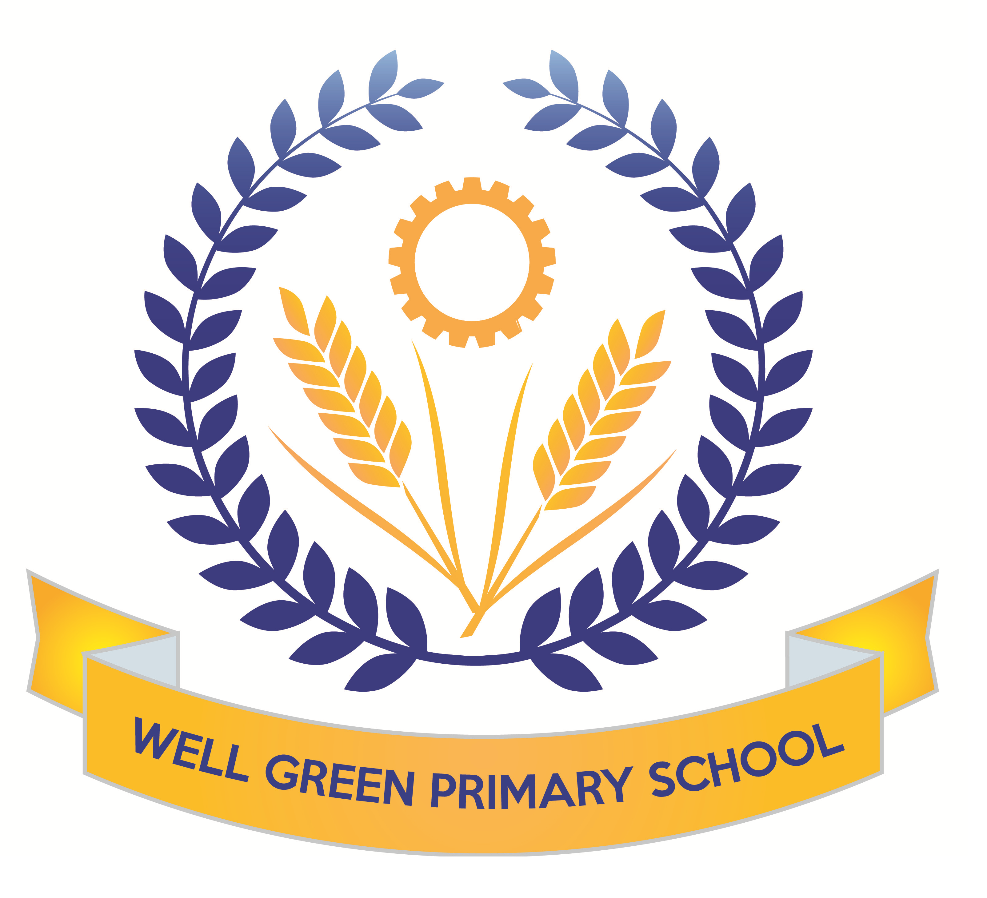

This half term (Summer 1), Year Six will be learning about the following topics:
English | Texts: descriptive about favourite meal, newspaper article about Michael’s disappearance and non-fiction information text about wolves from North America  Reading- comprehension skills and revision of question types for tests (fact/ opinion and true/ false) and 3 mark answers with PEE (point, evidence and explain)  Grammatical terminology, syntax and punctuation rules and their application in preparation for the SPAG test.  Spelling: Revision of key word list for Y3/4 and Y5/6  consolidation of spelling rules, using known root words, prefixes and suffixes.
English targets | - To revise all key concepts of SPAG covered and know the key terminology  - To be able to identify different types of pronouns- relative, personal and possessive  - To be able to spell words from the key words list from Y3/4 and Y5/6 (as many as possible)  - To recognise the past perfect and past progressive tenses and be able to use these  - To be able to identify words as conjunctions or prepositions in sentences  - To be able to use a full range of punctuation in writing and apply key spellings and use neat handwriting
Maths | Revision of formal written and mental calculation methods for +, -, x & ÷.  Shape and space - Perimeters and areas of 2D/3D shapes.  Data handling - extracting information from tables, pie charts, bar charts and line graphs  Money and real life problems – estimating and checking using the inverse or equivalent calculations. Fractions, decimals and percentages. Ratio and proportion. Algebra revision of formulae and nth term.  Revision of all areas and reasoning skills
Maths targets | - To revise all key concepts covered in Maths  - To develop calculations skills using written arithmetic, including to calculate written division with a formal method with decimal and fraction remainders  - To be able to solve multi-step problems using reasoning  - To be able to identify different parts of a circle  - To be able to use line graphs and conversion graphs to solve problems
Science | General consolidation and revision of all key areas of study in KS2 in preparation for assessment. Y6 will complete Science SAT papers in May (week 6 after SATs week)  Continuation of work on electricity:  We will construct circuits in parallel and series and test the brightness of bulbs and make buzzers and switches operate to link with our work in DT to create working burglar alarm systems  We will also begin to cover the topic ‘evolution and inheritance’ and begin to study the theory of Charles Darwin and how species have evolved, including a focus on dog breeds and inherited characteristics.
Computing | Use of SPAG.com, My Maths and BBC revise wise websites for revision purposes.  Working with Mrs Oldham on a unit: We Are Computational Thinkers  Exploring a range of algorithms for searching, sorting and approaching problems in mathematics.
Geography | We will begin our work in Geography based on North America and the USA.  We will be mapping the states and countries and learning about the geographical significance of this part of the world. We will study climate regions, tourist attractions, agriculture and industry patterns and the landscapes.
DT/Art | This half term, the children will continue to develop their use of science and electrical circuits and design and make an electrical item such as a burglar alarm.  We will also create art work based on the theme on North America, using printing techniques for city landscapes.
Music | Performance songs-singing in two parts and accompaniments  Beginning to learn songs for the performance and develop music to accompany.
P.E. | The children will also develop their cricket skills using the new equipment in school to practise ball control, passing techniques and matches. We will be having coaching sessions from Miss George about cricket and tactics.  Tennis- weekly sessions to develop skills for tennis and work on matches and develop scoring systems.
R.E. | Beliefs and Practices  Islam and Humanism  The life and teachings of the Prophet Muhammad linked to work in history in Summer 2 on Ancient Islamic Civilisations  Visit for curriculum enhancement to develop knowledge and understanding of Islamic faith and practices,
P.S.H.E. & Citizenship | Changes: What it feels like to belong to a group. Unwanted changes.  Feelings brought on by change & the need to belong.  SRE Week 20/5/19  Health & Fitness: Safety with drugs ,Alcohol/smoking. Food & Diet.

Most weekly homework and revision will be handed out on Friday, to be returned to school by the following Wednesday. Children have revision guides and SPAG.com accounts/ My Maths access to complete any additional revision you feel is necessary for your child.

Y6 Homework Club will continue until the week beginning 6th May before children complete their SATs tests.

Spelling Test: Friday Mental Arithmetic Test: Thursday
Cricket: Friday PE: Monday (Tennis)

Please can you also ensure your child has the correct equipment required for school: A blue cartridge pen with spare refills, pencil, ruler, glue stick and eraser. They also require a named water bottle.

Thank you for your continued support and co-operation.

Mrs Burnham

Key stage 2
The key stage 2 tests are timetabled from Monday 14th May to Thursday 17th May 2018.
There is a timetable below showing the details of the tests being held in school for the week commencing 14th May for the Y6 children.
Please ensure children arrive in school promptly this week and have a good night’s sleep and good breakfast to enable them to achieve their very best during these external exams.
Results of the tests will be published in July and will be reported to parents in the end-of-year reports.
Date | Activity
Monday 14th May 2018 | English grammar, punctuation and spelling Paper 1: questions  45 mins
Monday 14th May 2018 | English grammar, punctuation and spelling Paper 2: spelling  15 mins
Tuesday 15th May 2018 | English reading  1 hour
Wednesday 16th May 2018 | Mathematics Paper 1: arithmetic  30 mins
Wednesday 16th May 2018 | Mathematics Paper 2: reasoning  40 mins
Thursday 17th May 2018 | Mathematics Paper 3: reasoning  40 mins
Friday 18th May 2018 | Writing assessment  Mixed paper  1.5 hours

Science assessments undertaken during Week 6 (21st May onwards and Summer 2 half term)

