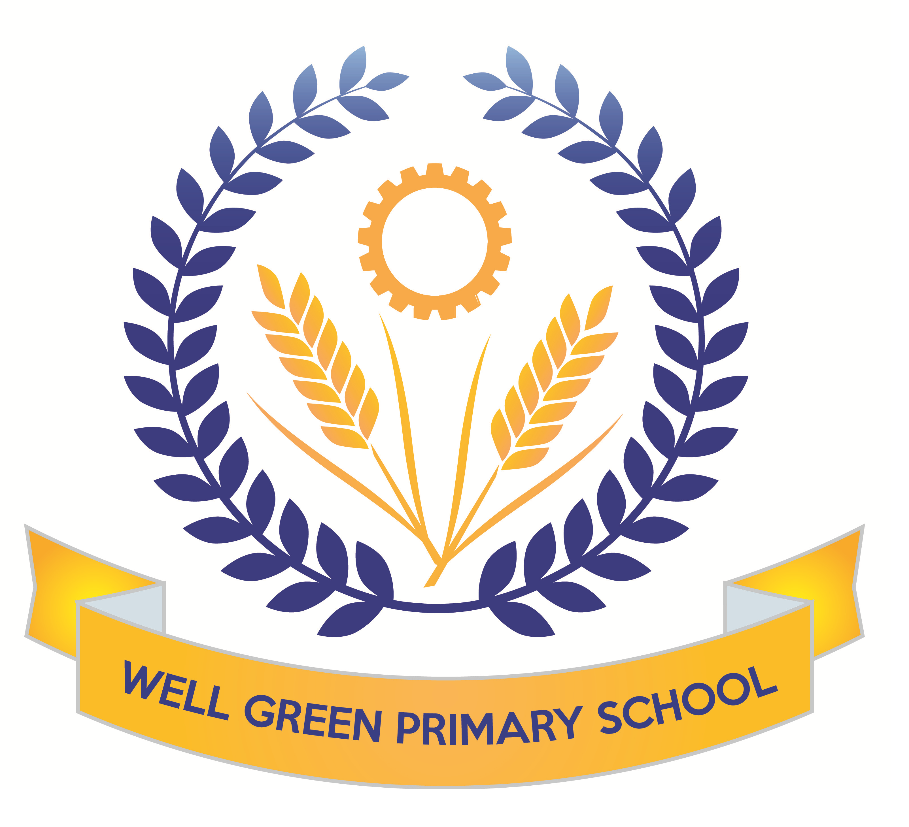

This half term (Summer 1), Year Six will be learning about the following topics:
English | Texts: descriptive about favourite meal, newspaper article about Michael’s disappearance and non-fiction information text about wolves from North America  Reading- comprehension skills and revision of question types for tests (fact/ opinion and true/ false)  Grammatical terminology, syntax and punctuation rules and their application in preparation for the SPAG test.  Spelling: Revision of key word list for Y3/4 and Y5/6  consolidation of spelling rules, using known root words, prefixes and suffixes.
English targets | - To revise all key concepts of SPAG covered and know the key terminology  - To be able to identify different types of pronouns- relative, personal and possessive  - To be able to spell words from the key words list from Y3/4 and Y5/6 (as many as possible)  - To recognise the past perfect and past progressive tenses and be able to use these  - To be able to identify different types of determiners  - To be able to use a full range of punctuation in writing and apply key spellings and use neat handwriting
Maths | Revision of formal written and mental calculation methods for +, -, x & ÷.  Shape and space - Perimeters and areas of 2D/3D shapes.  Data handling - extracting information from tables, pie charts, bar charts and line graphs  Money and real life problems – estimating and checking using the inverse or equivalent calculations. Fractions, decimals and percentages. Ratio and proportion. Algebra revision of formulae and nth term.  Revision of all areas and reasoning skills
Maths targets | - To revise all key concepts covered in Maths  - To develop calculations skills using written arithmetic, including to calculate written division with a formal method with decimal and fraction remainders  - To be able to solve multi-step problems using reasoning  - To be able to identify different parts of a circle  - To be able to use line graphs and conversion graphs to solve problems
Science | General consolidation and revision of all key areas of study in KS2 in preparation for assessment. Y6 will complete Science SAT papers in May (week 5 after SATs week)  Continuation of work on electricity:  We will construct circuits in parallel and series and test the brightness of bulbs and make buzzers and switches operate to link with our work in DT to create working burglar alarm systems  We will also cover the topic ‘evolution and inheritance’ and begin to study the theory of Charles Darwin and how species have evolved, including a focus on dog breeds and inherited characteristics.
Computing
Geography | We will begin our work in Geography based on North America and the USA.  We will be mapping the states and countries and learning about the geographical significance of this part of the world. We will study climate regions, tourist attractions, agriculture and industry patterns and the landscapes.
DT/Art | This half term, the children will continue to develop their use of science and electrical circuits and design and make an electrical item such as a burglar alarm.  We will also create art work based on the theme on North America, using printing techniques for city landscapes.
Music | Performance songs-singing in two parts and accompaniments  Beginning to learn songs for the performance and develop music to accompany.
P.E. | Athletics- we will cover a range of outdoor athletic lessons to develop our skills and technique  with long and high jumping, throwing and various distances of running.  The children will also develop their cricket skills using the new equipment in school to practise ball control, passing techniques and matches.
R.E. | Beliefs and Practices  Islam and Humanism  The life and teachings of the Prophet Muhammad linked to work in history in Summer 2 on Ancient Islamic Civilisations  Visit to Islamic Cultural Centre in Hale for curriculum enhancement to develop knowledge and understanding of Islamic faith
P.S.H.E. & Citizenship | Changes: What it feels like to belong to a group. Unwanted changes.  Feelings brought on by change & the need to belong.  SRE Week (23/5/16) About Me: Why are girls & boys bodies are different. Puberty- hygiene, emotions. Conception of babies, pregnancy and child birth.  Health & Fitness: Safety with drugs ,Alcohol/smoking. Food & Diet.

Most weekly homework and revision will be handed out on Friday, to be returned to school by the following Wednesday. Children have revision guides and SPAG.com accounts/ My Maths access to complete any additional revision you feel is necessary for your child.

Y6 Homework Club will continue until the week beginning 8th May when children complete their SATs tests.

Spelling Test: Friday Mental Arithmetic Test: Thursday
Cricket: Wednesday PE: Monday (Athletics and Cricket)

Please can you also ensure your child has the correct equipment required for school: A blue cartridge pen with spare refills, pencil, ruler, glue stick and eraser. They also require a named water bottle.

Thank you for your continued support and co-operation.

Miss Burnham

Key stage 2
The key stage 2 tests are timetabled from Monday 8 May to Thursday 11 May 2017.
There is a timetable below showing the details of the tests being held in school for the week commencing 8th May for the Y6 children.
Please ensure children arrive in school promptly this week and have a good night’s sleep and good breakfast to enable them to achieve their very best during these external exams.
Results of the tests will be published in July and will be reported to parents in the end-of-year reports.
Date | Activity
Monday 8 May 2017 | English reading  1 hour
Tuesday 9 May 2017 | English grammar, punctuation and spelling Paper 1: questions  45 mins
Tuesday 9 May 2017 | English grammar, punctuation and spelling Paper 2: spelling  15 mins
Wednesday 10 May 2017 | Mathematics Paper 1: arithmetic  30 mins
Wednesday 10 May 2017 | Mathematics Paper 2: reasoning  40 mins
Thursday 11 May 2017 | Mathematics Paper 3: reasoning  40 mins
Friday 12 May 2017 | Writing assessment  Mixed paper  1.5 hours

