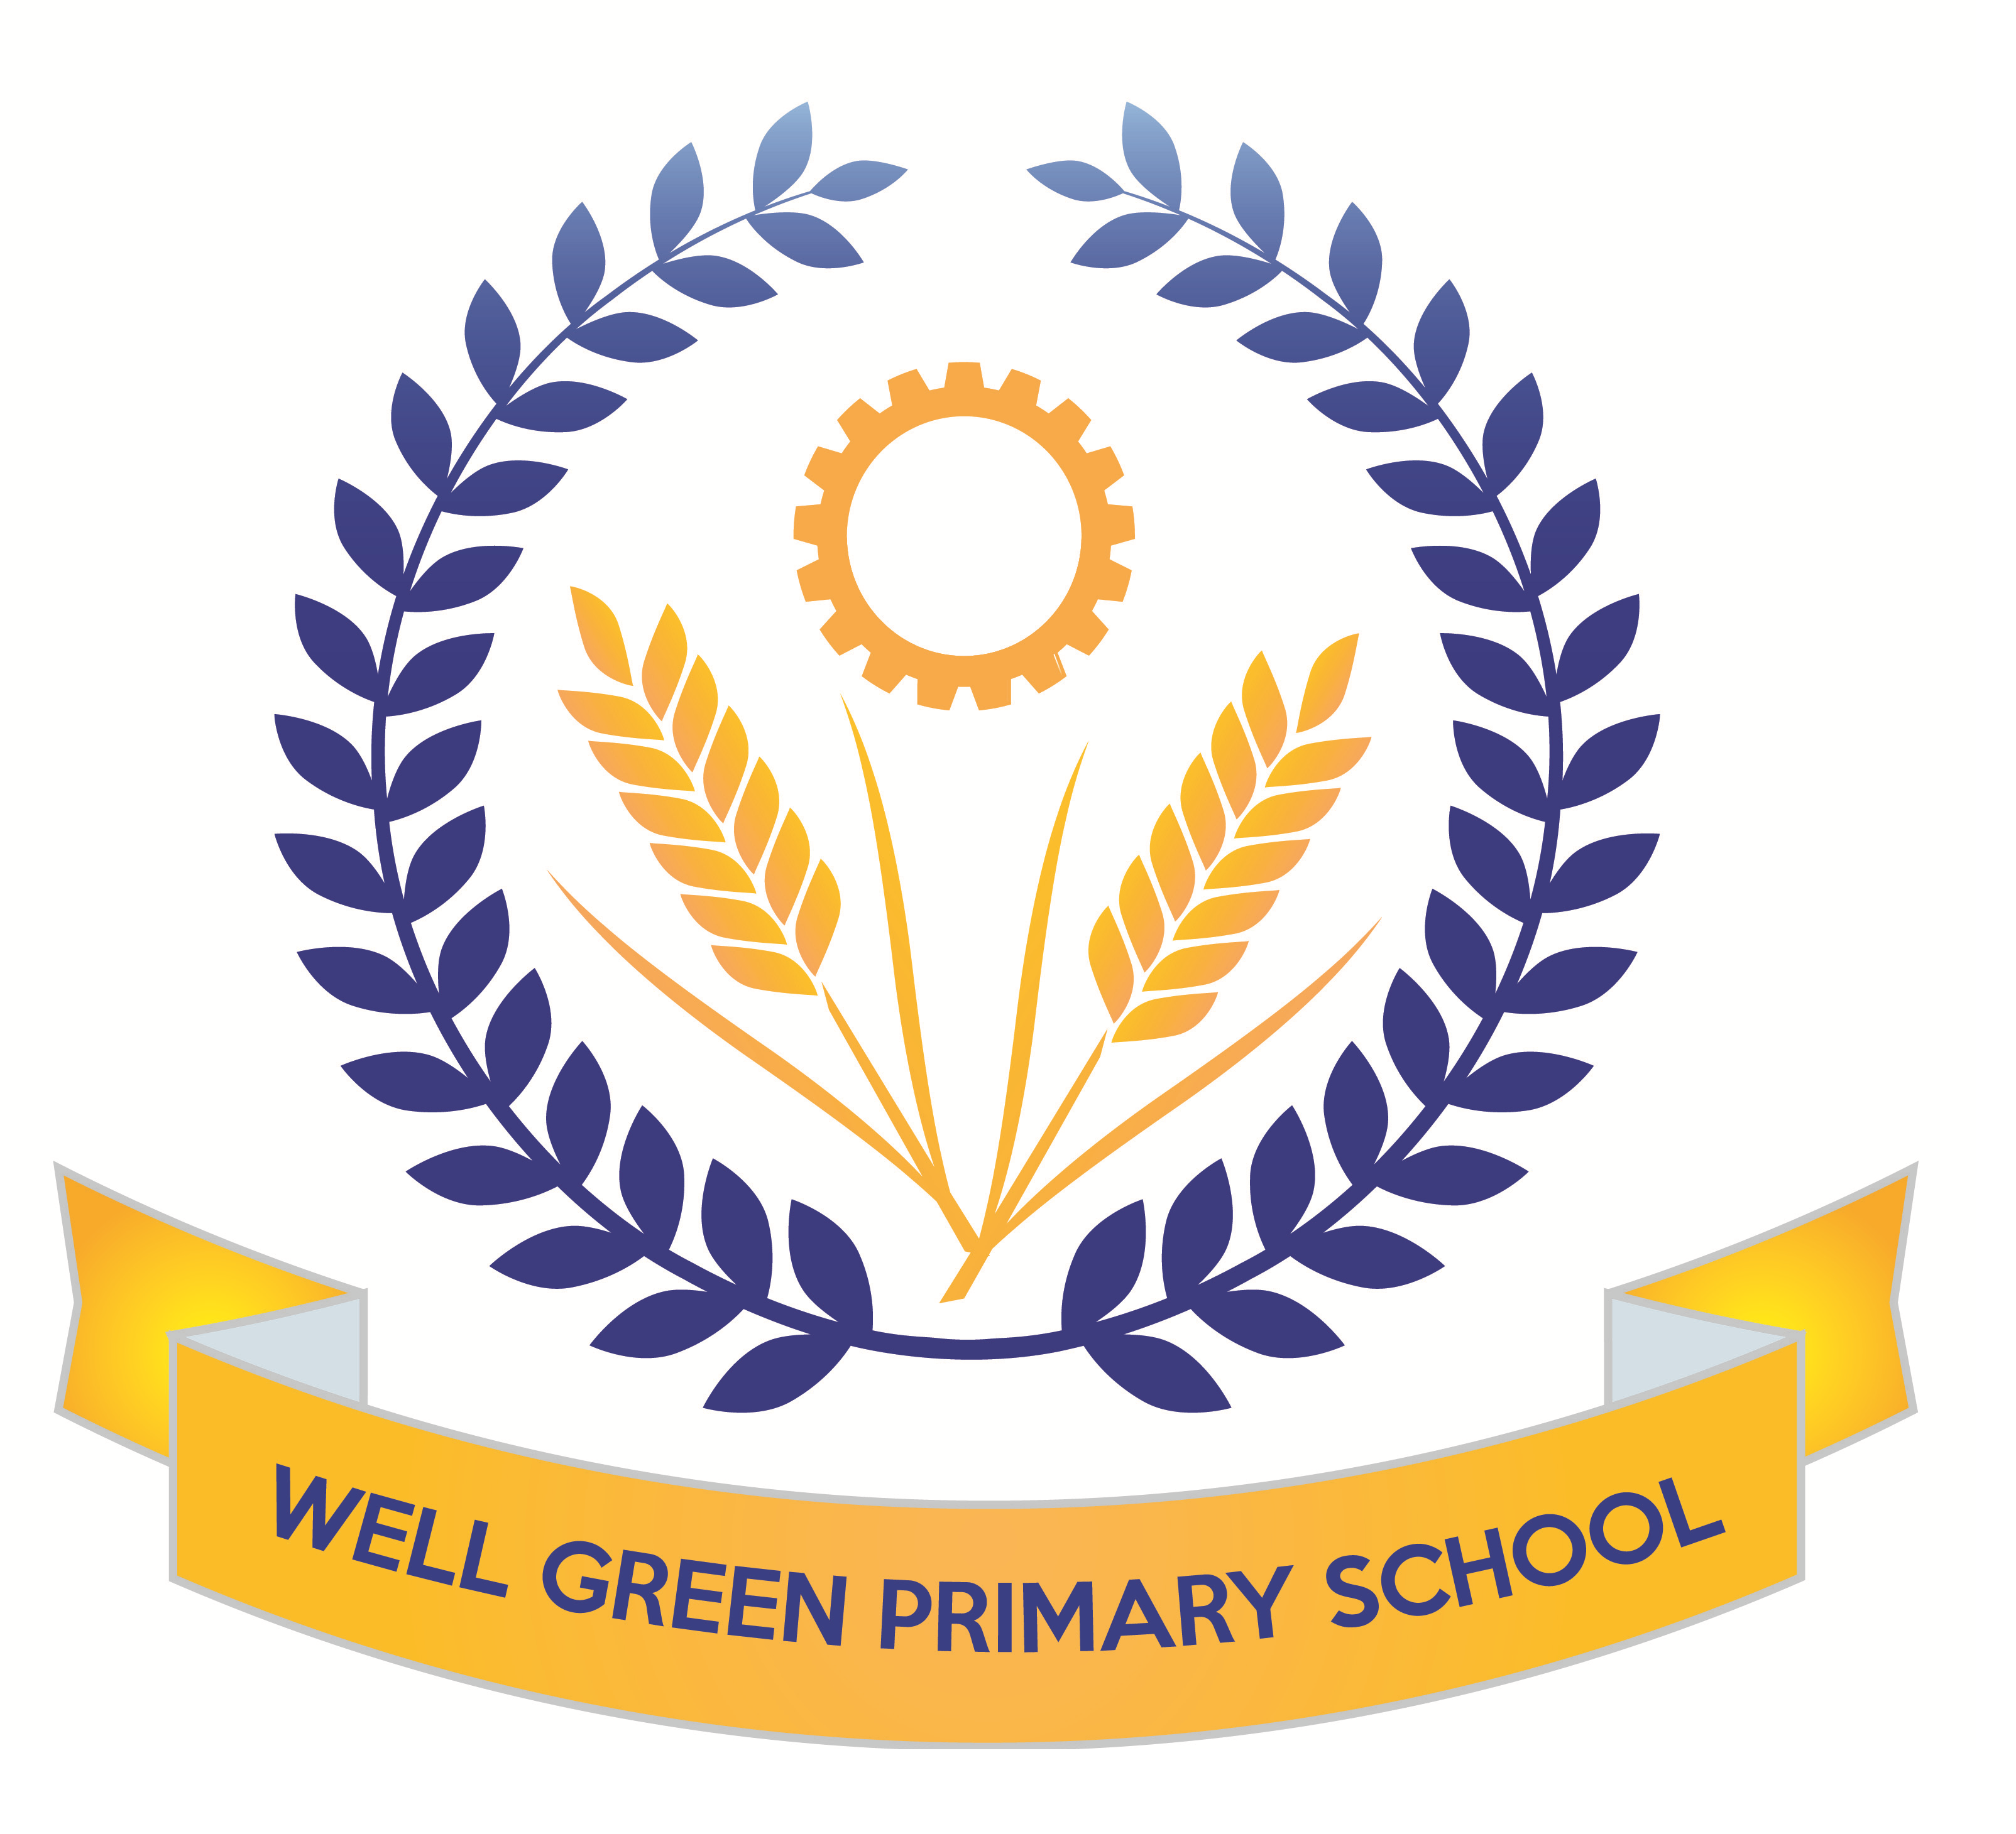

This half term (Summer 1), Year Six will be learning about the following topics:
English | Texts: descriptive about favourite meal, newspaper article about Michael’s disappearance and non-fiction information text about wolves from North America  Reading- comprehension skills and revision of question types for tests (fact/ opinion and true/ false)  Grammatical terminology, syntax and punctuation rules and their application in preparation for the SPAG test.  Spelling: Revision of key word list for Y3/4 and Y5/6  consolidation of spelling rules, using known root words, prefixes and suffixes.
English targets | - To revise all key concepts of SPAG covered  - To be able to identify different types of pronouns- relative, personal and possessive  - To be able to spell words from the key words list from Y3/4 and Y5/6 (as many as possible)  - To recognise the past perfect and past progressive tenses and be able to use these  - To be able to use a full range of punctuation in writing and apply key spellings and use neat handwriting
Maths | Revision of formal written and mental calculation methods for +, -, x & ÷.  Shape and space - Perimeters and areas of 2D/3D shapes.  Data handling - extracting information from tables, pie charts, bar charts and line graphs  Money and real life problems – estimating and checking using the inverse or equivalent calculations. Fractions, decimals and percentages. Ratio and proportion. Algebra revision of formulae and nth term.  Revision of all areas and reasoning skills
Maths targets | - To revise all key concepts covered in Maths  - To develop calculations skills using written arithmetic, including to calculate written division with a formal method with decimal and fraction remainders  - To be able to solve multi-step problems using reasoning  - To be able to identify different parts of a circle  - To be able to use line graphs and conversion graphs to solve problems
Science | General consolidation and revision of all key areas of study in KS2 in preparation for assessment.  Y6 will complete Science SAT papers in May (week 5 after SATs week)  Continuation of work on electricity:  We will construct circuits in parallel and series and test the brightness of bulbs and make buzzers and switches operate. We will use correct scientific symbols to record circuits. The children will carry out practical investigations in addition to developing their understanding of electrical safety and sustainable energy sources.
ICT | Searching the internet for information to support other curriculum areas.  Control and monitoring using ICT  Using the Ipads and apps to generate sentence types with Alan Peat for revision
Geography | We will begin our work in Geography based on North America and the USA.  We will be mapping the states and countries and learning about the geographical significance of this part of the world. We will study climate regions, tourist attractions, agriculture and industry patterns and the landscapes.
DT/Art | This half term, the children will continue to develop their use of science and electrical circuits and design and make an electrical item such as a burglar alarm.  We will also create art work based on the theme on North America, using printing techniques for city landscapes.
Music | Performance songs-singing in two parts and accompaniments  Beginning to learn songs for the performance and develop music to accompany.
P.E. | Athletics- we will cover a range of outdoor athletic lessons to develop our skills and technique  with long and high jumping, throwing and various distances of running.  The children will also develop their tennis skills using the new equipment in school to practise ball control, passing techniques and matches.
R.E. | Local study – Independent project on different faiths and religions.
P.S.H.E. & Citizenship | Changes: What it feels like to belong to a group. Unwanted changes.  Feelings brought on by change & the need to belong.  SRE Week (23/5/16) About Me: Why are girls & boys bodies are different. Puberty- hygiene, emotions. Conception of babies, pregnancy and child birth.  Health & Fitness: Safety with drugs ,Alcohol/smoking. Food & Diet.

Most weekly homework and revision will be handed out on Friday, to be returned to school by the following Wednesday. Children have revision guides and SPAG.com accounts/ My Maths access to complete any additional revision you feel is necessary for your child.

Y6 Homework Club will continue until the week beginning 9th May when children complete their SATs tests.

Spelling Test: Friday Mental Arithmetic Test: Thursday
Tennis: Wednesday PE: Thursday (Athletics and Cricket)

Please can you also ensure your child has the correct equipment required for school: A blue cartridge pen with spare refills, pencil, ruler, glue stick and eraser. They also require a named water bottle.

Thank you for your continued support and co-operation.

Miss Burnham

