Dear Year Four,
The Literacy homework this week is linked to our Tudor Topic and gives you the chance to do some research and create a mini project.
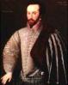
You have been asked to research one or more of the Tudor explorers, possible examples include:
- Christopher Columbus
- Sir Francis Drake
- Sir Walter Raleigh
- John Cabot
A good place for you to begin your research may be
http://resources.woodlands-junior.kent.sch.uk/homework/tudors/explorers.htm
Please present your work on A4 paper, maximum two sheets (only use one side so we can display them!) and think about pictures, information, maps and organisation.
You may use printed images, maps and photographs, but please handwrite your information in ink pen, using colours for headings and illustrations.
I look forward to seeing your efforts, I know how interested you all are in this topic! To allow you chance to do this work well, you have two weeks to complete your project.
The deadline will be Wedensday 2nd October 2013.
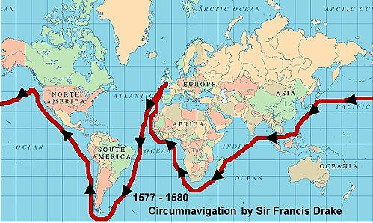
Good luck!
Miss Burnham

