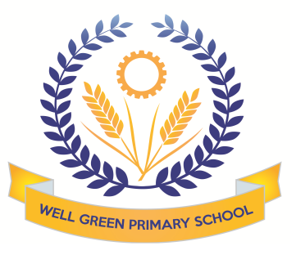

**This half term (Summer 2)**

**Year 4 will be learning about the following topics**

|  |  |
| --- | --- |
| English | In English this term we will continue to build on our knowledge of various spelling patterns. We will develop our understanding and use of pronouns as well as consolidating our knowledge and identification of the different parts of speech and sentence structure. We will produce writing linked to one of our Science topic, Habitats. We will also read and write poetry. |
| This half term our targets will be:   * To write a non-chronological report * To choose nouns or pronouns appropriately for clarity and cohesion * To listen to and discuss a wide range of fiction, poetry (recognising some different forms of poetry) plays, non-fiction and reference books or textbooks * To write poetry in response to different stimuli |
| Mathematics | In maths this term we will be focusing on geometry. We will classify and compare angles, draw lines of symmetry and complete symmetrical drawings. Lastly, we will be learning about coordinates and how to describe translation of shapes on a grid. |
| This half term our targets will be:   * Identify and draw lines of symmetry and complete symmetrical drawings * Classify and compare angles * Classify and compare the properties of 2d shapes * Plot coordinates and describes translations of shapes on a grid. |
| Science | In Biology we will learn about how muscles expend and contract. We will also learn about how changes to their habitats affect animals, and lastly we will be covering adaptations in animals. In Chemistry, we will learn about solids, liquids and gases, and we will be conducting an experiment to find out about evaporation. |
| Computing | Our topics will be ‘Effective Searching’ and ‘Animation’. We will be finding out how to use internet search engines to find information that we need. We will also be learning about how to make moving pictures by using a series of stills. |
| History | We will be continuing to study the Romans. We will learn about their religious beliefs and how these changed. We will also be learning about how they spent their leisure time, including gladiator battles! |
| Design & Technology | Our topic is ‘Levers and Linkages’ and we will create moving pictures. We will also be making healthy pizzas. |
| Music | Working with Mrs Cooper, we will be exploring descriptive sounds. We will also be learning songs in preparation for the summer concert. |
| R.E. | We will continue learning about ‘Following a Christian Way of Life’ with Mrs Oldham. The children will continue to focus on how Christians lead their life and how they worship Jesus. |
| P.S.H.E. and Citizenship | The theme for this half term is ‘Changes’. We will be discussing strategies for how we deal with changes in our lives. |
| French | We will spend this half term revising and practising the French that we have learned in Year 4. |

Homework, usually Maths, English and any spelling and multiplication tables will be given out on a Friday to be handed in by the following Wednesday. Please read with your child regularly and record this in their reading record as it is part of their weekly homework. Times tables and spelling test take place every Thursday.

PE will be on Tuesdays and Wednesdays. Please ensure that your child has something suitable for all weathers, including a hat and water bottle, if the weather is warm.

Please can you also ensure your child has the correct equipment required for school: **A blue fibre tip pen with spares, pencil, sharpener, ruler and eraser. They also require a named water bottle.**

If you have any concerns please don’t hesitate to come and see me.

Thank you for your support and co-operation.

Mrs Simon