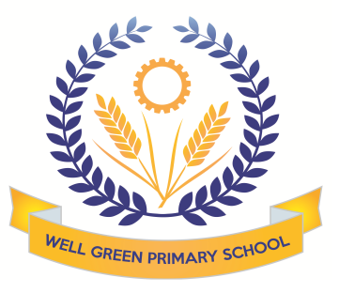

**This half term (Summer 1)**

**Year 4 will be learning about the following topics**

|  |  |
| --- | --- |
| English | In English we will be reading ‘Charlotte’s Web’. We will explore various spelling patterns including suffixes. We will consolidate our knowledge and use of the apostrophe. We will develop our writing skills by writing balanced and persuasive texts, supporting our topic and Science work. |
| This half term our targets will be   * To revise various spelling patterns including suffixes ‘ion’ and ‘ly’ and words ending in ‘gue’ and ‘que’ * To identify the subordinate clause in a sentence * To continue to develop use and understanding of apostrophes for contractions and possession * Read stories from other cultures * To write a balanced argument * To produce persuasive writing |
| Mathematics | In Maths this term we will be learning how to calculate the perimeter and area of shapes. We will compare and order angles of different sizes, classify shapes based on their properties, and look for lines of symmetry. Lastly, we will learn how to plot coordinates and describe the translation of shapes on a grid. |
| This half term our targets will be:   * Convert units of mass, volume and length. * Compare, order, measure and start to draw angles * Solve problems involving scale reading * Measure area and perimeter * Plot coordinates and describe translation of shapes on a grid |
| Science | This term our theme is ‘Healthy Lifestyles’. We will learn about healthy, balanced diets and about how exercise is important for our bodies. We will also explore the effects on the human body of tobacco, alcohol and other drugs, and how these relate to their personal health. |
| Computing | Our topic this half term is ‘Using Logo’. Children will learn common commands and constructs of the Logo programming language. They will develop their ability to compose algorithms for drawing mathematical structures and turn these into Logo code. |
| Geography | We will be looking at ‘Europe’, which countries make up this continent, their capital cities, similarities and differences, customs and traditions. |
| Design & Technology | We will be making pizza this half term. This will involve food preparation using a recipe to measure and mix ingredients. The children will use a range of techniques. This will support our work in Science. |
| P.E. | P.E. on Mondays will be a continuation of our yoga sessions. On Fridays, we will be doing Tennis. We will learn the skills and tactics of the game as well as developing team work skills. |
| Music | Working with Mrs Cooper, we will be learning about instruments and the orchestra. |
| R.E. | Working with Mrs Oldham we will be learning about ‘Following a Christian Way of life’. The children will focus on how Christians lead their life and how they worship Jesus. |
| P.S.H.E. and Citizenship | The theme for this half term is ‘Changes’. We will explore what it feels like to belong to a group, unwanted changes and feelings brought on by change. |
| French | In French this half term, we will be listening to the “Carnival of the animals”. We will learn lots of new animal vocabulary and construct sentences of our own based on the story. |

Homework, usually Maths, English, spelling and multiplication tables will be given out on a Friday to be handed in by the following **Wednesday**. Please read with your child regularly and record this in their reading record as it is part of their weekly homework. Times tables and spelling test take place every Thursday.

The outdoor games lessons are on **Fridays**. An outdoor kit is needed for these lessons. Please ensure that your child has something suitable for all weather. Indoor P.E. lessons are on **Mondays. Children who have earrings are asked to remove them and leave them at home on P.E. days or remove them and keep them safe themselves at school. If ears have been pierced recently the children are responsible covering their own earrings with tape.**

Please can you also ensure your child has the correct equipment required for school. Your child will need a blue fibre tip pen with spares, pencil, sharpener, ruler and eraser. They also require a named water bottle.

If you have any concerns please don’t hesitate to come and see me.

Thank you for your support and co-operation.

Mrs Simon