Step1

Use objects your child can pick up and move rather than drawing representations on paper. An example is below:

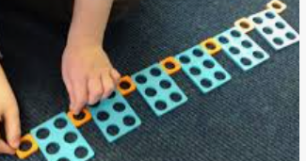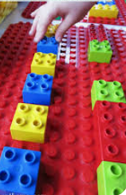

The above is an example of what mathematicians call ‘an ABABA pattern in concrete representation’

This means it is using ‘concrete’ objects that a child can pick up and move and is obviously using 2 types of objects alternately.

The example below is more difficult, and is called an ‘ABBABBAA’ pattern. This is not something children in Nursery need to know, or are expected to know, I am just showing an example. The example below has a deliberate error by the teacher, and the child has been asked to spot it, say what the error is and correct it. This would be more of an end of Reception/beginning of year 1 expectation.

