Friday 17th January
Communication and Language/Literacy
We have focussed on two texts this week: ‘The Three Little Pigs- An Architectural Tale’ and a book with the paintings of Paul Klee, which has many 2D shapes in that we’ve chatted about. https://www.youtube.com/watch?v=E3T_CEch_LU

Physical Development
We have been carrying soil, leaves and water around outside to build our core strength and arm, wrist and finger muscles. We’ve had a Disco Dough session, yoga and played a game called ‘Wake Up Mr Bear’.

Maths
We have been looking at position and space, positional language and routes in mathematics. We have learnt that triangles can be different sizes, colours and look different (scalene, right angled, isosceles) BUT ALL triangles have 3 sides. We have shown triangles upside down as well, as many children only think a triangle is a triangle if it looks like this: 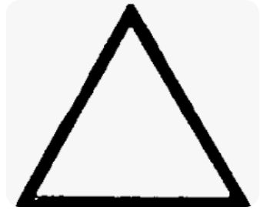. It is important to address these misconceptions early on.
We looked at the route the Wolf took in our story and chatted about it. We used vocabulary such as ‘first’ ‘second’ ‘third’ ‘top’ ‘bottom’ ‘next’ and ‘then’ . If you chat about routes with your child using these words, it will support them and help them move on with their learning.

Other Learning
In geography, we looked at the Sahara desert, as we learnt last week that Antarctica is a desert, as it does not get much rain or snow. Some deserts are hot, but some deserts (Antarctica) are very cold.
In art, we’ve looked at the work of Paul Klee who used many shapes to make pictures. We learnt that he used to cook food and sometimes stir his food with his paintbrush if he was thinking about painting.
In science, we learnt about starlings. We saw a robin eating the bird cakes we made last week, so we were very excited about that. 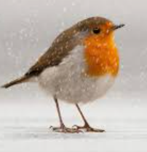

Homework
Please re-read the text we have been looking at in Literacy.
For Maths homework, please LEARN the shape song. It is important your child does not just NAME the shape, but sings all the words, as these teach the child about the PROPERTIES of each shape.
https://www.youtube.com/watch?v=OEbRDtCAFdU

