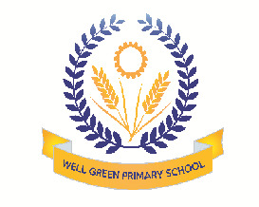

STARTING SCHOOL
AT
WELL GREEN PRIMARY
This booklet is for you and your family. It tells you all about the different things that happen at School. We hope that you enjoy looking through it, and look forward to seeing you soon when you start school.

You are Special

You will take it in turns with your friends to be pupil and citizen of the week. Each time you are either pupil or citizen of the week you will have a certificate to take home. Stickers and stamps are awarded throughout the day and these can be put on your special sticker chart, when you have ten stamps, you will receive a Head Teachers reward.
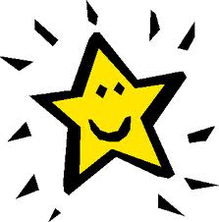

Your Things

You will have your own coat peg with your name and a picture on it. You can hang your coat and PE kit bag here. There is a trolley to put your lunchbox and water bottle on if you have one. In the classroom you will have a tray with your name on it. You can keep your things in this and your book bag and special work. Letters for home will go in your book bag together with your school reading book when you have one.

School

Arriving in the Morning

When you come to school you will wait on the playground with your grown-up. Your teacher will come to collect you at 9:00 am. We may open the doors earlier, especially if the weather is bad. Use the playground gate to come into the playground.
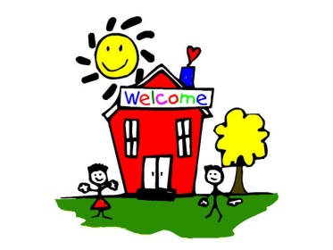
Snack

During the playtimes you will be able to have a piece of fruit to eat. The fruit is provided free to all Reception and Key Stage One children. You can bring your own fruit or healthy snack from home. You will need to bring in your own water bottle. NO CRISPS, NUTS, CHOCOLATE, SWEETS OR BISCUITS ARE TO BE BROUGHT IN.

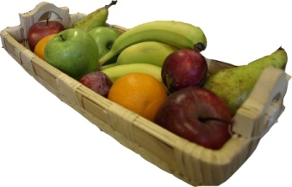

Assemblies

Each day at school we all meet together for an assembly. Sometimes it will be with all the children in the school. At other times it will be the younger children in school or just your class. You will be able to hear a story and sing songs. On Friday mornings we have a Celebration Assembly when we share with other children and teachers our special work.

Lunch Time

When you stay at school for your lunch you will eat it in the hall, at a table, with the rest of your class. You can bring a packed lunch in a special box from home. Please make sure it has your name on, so you will not lose it. You may like to have a special cooked lunch from school instead.
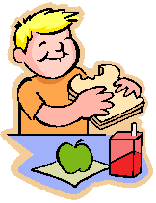
Home Time

You go home at 3:15 pm and you will be collected from the playground by your Mum, Dad or someone else you know. Your teacher will make sure they see your grown-up before you can go.
What will you do at school?

Reading

We hope you enjoy sharing books with your friends and families and are getting to know lots of rhymes. At school you hear stories every day. The book corner in your classrooms is a special place to sit while you are looking at and reading books. There are books about everything- dinosaurs, pirates and trains, fairytales and puppy dogs and lots more besides. At first you will remember the stories just by looking at the pictures. With lots of practice you will begin to use your phonics to help you sound out and blend the sounds in the words. You will have a reading record book to keep in your book bag. Your grown-up can write down when you read to them and how you got on.
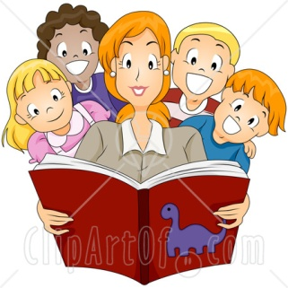
Writing

Writing is FUN! At school you will learn how to form your letters correctly and also how to write sentences. It would be great if you could write some letters in your own name when you start school just using a capital letter at the start of it. Don't worry if you can't; you will soon learn at school.
We write while we play all the time; in the role play, outside and on the writing table.
When you have been at school a while you will begin to know, recognise and write the sounds you hear in words. Then you will quickly begin to write sentences too!

You will be able to do lots of other activities at school to help with your writing. These include tracing over pictures, drawing patterns, colouring, making models with plasticine, cutting and drawing.
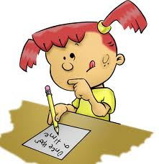
Mathematical Development

Before you come to school you can do lots of things at home with your family that will help you with your maths:
- sort blocks by colour and size
- fit jigsaw puzzles together
- learn nursery rhymes and number songs such as "Five currant buns"
- play lots of games where you have to throw a dice and move along a board
- cooking – talk about which things are heavy and light, how much you need and counting and sharing
- talking about your family ..... who is the youngest, oldest, tallest or shortest
- talk about time using words such as morning, night, yesterday, tomorrow and next week
- at bath time look at which things float or sink; is the bath full or empty?
- when you are getting dressed look at things you put on first and last, which is the back and front, how many buttons have you got?
- at meal times you can lay the table and make sure you have enough knives and forks.
- when you go shopping you can look at the numbers and look at coins. You can look at the shape, size and colour of the boxes.
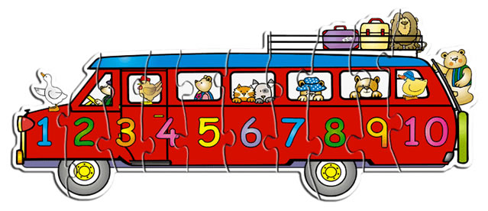

At school we will do lots of mathematical activities. You will do lots of exciting things, such as measuring, weighing, looking at shapes, making models, learning numbers, following directions and using the computer.



Physical Development

At school you will be able to do PE at least once a week, both in the hall and outdoor area. You can bring your kit in a PE bag and leave it at school until the holidays. PE can be dancing to music, simple gymnastics using climbing equipment, games with hoops, ropes and balls and using a variety of outdoor equipment.
When you get changed for PE you should be able to take off and put on most of your clothes by yourself. Your teacher will help you with things you find hard. Do practice getting changed at home.
Your PE kit and all of your other clothes should have your name sewn in so that they don't get lost or mixed up with someone else’s, as everyone’s kit looks the same!

Activity Time

At school there are lots of things in the outdoor and indoor area for you to play with. Here are some of the things you will find:
- role play and dressing up clothes so that you can be a doctor, a princess, a policeman or policewoman or a fire-fighter.
- puppets and a puppet show
- construction kits to make large models using nuts and bolts
- large and small building blocks and lots of other things to make models
- a farm with buildings and lots of animals
- games and jigsaws
- plasticine and playdough
- a sand tray and a water tray
- small world toys
- computers and an interactive whiteboard with lots of interesting programmes
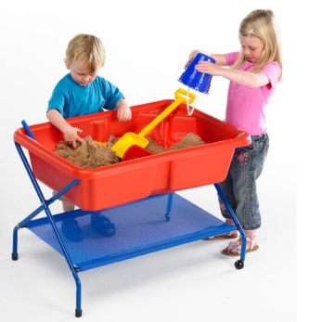

Creative Activities

At school you will be able to do lots of creative things. You can paint, stick, make models, use clay and play in the sand and the water.
We have aprons at school to keep your uniform clean and also to keep you dry when you play in the water.

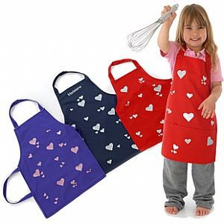

Library

You will have the opportunity to go to the Infant Library every week to choose a book to share with your grown up at home.

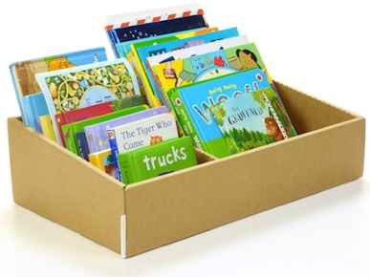

Activities at Home

Once you are settled in school you will take home activities which you can do with your grown up. This will be a reading, writing or mathematical activity. Furthermore, your grown up will receive a letter to inform them of what we have been learning to do in class during the week.

Picture Books

Initially you will bring home a picture book. Books with no words are actually best for boosting your language skills. Research has proved that if you and your grown up talk about the pictures and answer questions it exposes you to complicated vocabulary and advances your language. So, please enjoy these with your grown up.

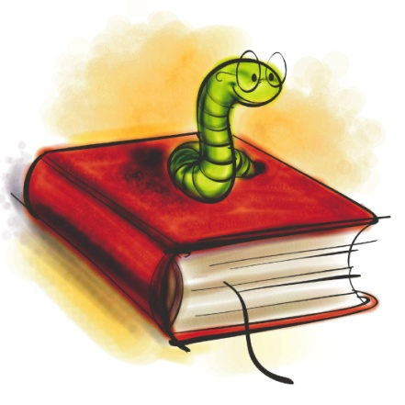
Early Years Foundation Stage Profile

When you have been at school a few weeks, your teacher will invite your grown-ups into school for a little "chat ". We will talk about all the different things you can do. These include looking at books, getting dressed, tidying up, colouring, counting and playing with other children. All these things make up your "Early Years Foundation Stage Profile".

Each term your grown-up will be invited to a Parents' Evening. They will be able to talk to your teacher about the progress you have made. They may be asked to help by doing special things at home with you.

We will take lots of photographs of you and write about all the great things you do in school too. These will go in your very special Learning Journey book. We hope you will bring in some things from home to share all the wonderful learning you do with your family. You can put these in your Busy Bee Book.

We hope this booklet has helped you and your family to know what will happen when you start school.
Remember, when you come to school you will learn lots of new things and have lots of fun with your teachers and your new friends.

