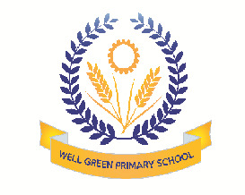
Welcome back! We hope you all had a great holiday. Our topic for this half term is: How do things grow? (Plants/ mini-beasts/ animals)The children will be focusing on:
Communication & Language | - Introducing language and vocabulary associated with plants, animals and mini-beasts. Discussing sounds, smells, textures and appearances
Physical Development | - Using music and dance to represent the growth and movement of plants and animals  - Using a range of large and small apparatus associated with gardening  - Moving in areas of limited space safely and with an awareness of others
Personal, Social & Emotional Development | - Talking about caring for and not damaging wildlife, plants, environment and creatures  - Taking responsibility for growing plants  - Sharing experiences/feelings related to animals and the natural environment
Literacy | - Talking about the letters that represent the sounds they hear in their names and other familiar words  - Recognising a story has a beginning, a middle and an end part. Using words such as: ‘setting’, ‘characters ‘events’
Mathematics | - Counting a collection of objects and checking the total  - Finding one more or one less from a group of up to 5/10 objects. Number problems  - Beginning to make sensible estimates
Understanding the World | - Beginning to understand living things have certain needs in order to survive and grow  - Starting to understand that living things change over time  - Looking closely at similarities, differences, patterns and changes in nature
Expressive arts and design | - Working with others on large scale pictures  - Printing patterns inspired by first hand observations of mini-beasts and plants  - Creating textured pictures

Thank you in anticipation of your support and co-operation. Well Green Primary School Nursery Staff

