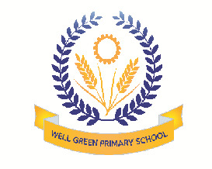
Welcome back! We hope you all had a great holiday. Our topic for this half term is: Winter The children will be focusing on:
Communication & Language | - Listening to stories with regularly repeated phrases and rhymes  - Developing talking & listening skills, for example, encouraging the children to tell their Talk Partner what they did during the lesson  - Model new vocabulary related to characters, props and places in the studied texts
Physical Development | - Using songs, rhymes and music with very distinct rhythms such as ‘Heads, Shoulders , Knees and Toes’  - Playing Where’s my space?, Follow my leader, Bean game and other games to practice moving safely and confidently around the space.  - Developing a pincer grip through picking up small items, finger painting etc
Personal, Social & Emotional Development | - Sharing books about different cultures. How do they live? What do they wear?  - Having an ‘Operation Tidy Up’ to keep our environment pleasant for all and safe for wildlife  - Developing self- selection plus dressing independently
Literacy | - Learning alliterative songs  - Developing writing skills using multi- sensory approach –with coloured sand, finger paint, soap flakes gloop etc  - Reading favourite stories and retell/act out
Mathematics | - Counting using fingers and hands – keep up the rhythm by clapping, patting knees, holding up a finger for each number and showing ‘high fives’  - Learning the formation of numerals through ‘Number Zoo’
Understanding the World | - Providing children with a variety of materials and helping them to name them and describe what they feel like  - Using walks around the local area to find signs of winter and observe how things are changing
Expressive arts and design | - Naming and looking at different ways of playing instruments  - Creating ‘Cold and Frosty ‘ pictures  - Creating a winter cave with texts & props

Thank you in anticipation of your support and co-operation. Well Green Primary School Nursery Staff

