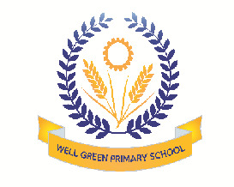
Welcome back! We hope you all had a great holiday. Our topic for this half term is: Spring/ Changes In Food The children will be focusing on:
Communication & Language | - Showing understanding of prepositions such as ‘under’, ‘on top’ and ‘behind’  - Building up a vocabulary about Spring and kitchen utensils/ cooking
Physical Development | - Exploring dance and body shape  - Handling tools and construction with increasing control and safely  - Developing fine motor skills
Personal, Social & Emotional Development | - Learning about rights and responsibilites  - Discussing personal memories and feelings relating to our topics  - Finding out about Shrove Tuesday and other celebrations
Literacy | - Practising letter formation (first/ family names)  - Identifying/ extending alliterative word lists  - Suggesting how a story may end  - Exploring information books
Mathematics | Touch counting larger amounts of objects  Comparing amounts: same/ fewer/ more  - Recognising/ creating simple patterns  - Using language such as ’heavier’ or ‘lighter’, ‘longer’ or ‘shorter’ to compare items
Understanding the World | - Practising using the Ipad, computer and digital camera  - Using the senses. Talking about change  - Examining objects and living things to find out more about them
Expressive Arts and Design | - Describing and exploring the texture of objects  - Using resources to create props to support role play  - Exploring sounds with various items both inside and outside the nursery

Thank you in anticipation of your support and co-operation. Well Green Primary School Nursery Staff

