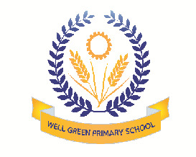
Welcome back! We hope you all had a great holiday. Our topic for this half term is: How do we get there? The children will be focusing on:
Personal, Social & Emotional Development | - Taking turns in conversations to listen, and then speak  - Explaining their own thinking  - Describing them self in positive turns and talk about their abilities
Physical Development | - Holding a pencil near point between first two fingers and thumb and use it with good control  - Showing a preference for dominant hand  - Forming recognisable letters using the correct sequence of movements
Communication & Language | - Asking their own questions about why things happen  - Using a range of tenses in their speech, eg play, playing, played  - Concentrating and sits quietly during group activity and carpet sessions  - Listening and responding to ideas expressed by others in conversation or discussion
Literacy | - Describing where a story takes place, what happens to the characters  - Saying the sounds in simple words and blend them together  - Learning which letters represent some of the sounds they hear
Mathematics | - Counting objects to 10 and beyond 10 in order  - Counting an irregular arrangement of up to 10 objects  - Beginning to use mathematical names for ‘solid’ 3d shapes and ‘flat’ 2D shapes, and mathematical terms to describe them
Understanding the World | - Talking about some of the things they have observed such as plants, animals and natural objects  - Talking about why things happen and how things work  - To know that information can be retrieved from computers
Expressive arts and design | - Exploring what happens when they mix colours  - Constructing with a purpose in mind, using a variety of resources  - Selecting tools and techniques needed to cut and join materials they are using

Thank you in anticipation of your support and co-operation.
Please ensure your child has sun cream applied before they arrive for each nursery session. They should bring a sunhat o cap to protect them on sunnier days, thank you.

