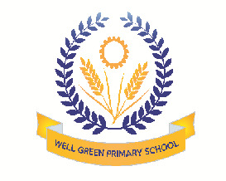
Welcome back! We hope you all had a great holiday. Our topic for this half term is: Who Goes To The Ugly Bug Ball? The children will be focusing on:
Communication & Language | - To respond to instructions involving a two-part sequence  - To introduce a storyline or narrative into their play  - To begin to understand ‘why’ and ‘how’ questions
Physical Development | - To jump off an object and lands appropriately  - To show increasing control over an object in pushing, patting, throwing, catching or kicking it  - To begin to form recognisable letters, starting top left of piece of paper (name, captions)
Personal, Social & Emotional Development | - To tolerate delay when needs are not immediately met, and may not always be met  - To explain own knowledge/ understanding, and asks appropriate questions of others  - To describe self in positive terms and talk about abilities
Literacy | - To continue a sound pattern with their voice and vary the pitch  - To copy ‘sound talk’ such as p-i-n  - To experience a variety of books and know, in English, print is read from left to right, and top to bottom
Mathematics | - To recognise numerals and select correct numeral to represent 1 to 5, then 1 to 10 objects  - To find 1 more or 1 less from a group of up to 5 objects, then 10 objects  - To order 2 items by length, height, weight or capacity
Understanding the World | - To look closely at similarities, differences, patterns and change  - To show care and concern for living things and the environment  - To know that information can be retrieved from computers
Expressive arts and design | - To experiment to create different textures  - To selects tools and techniques needed to shape, assemble and join materials they are using  - To choose particular colours to use for a purpose

Thank you in anticipation of your support and co-operation, Well Green Primary School Nursery Staff

