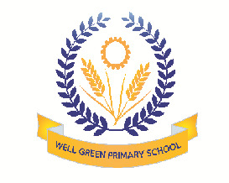

Welcome back! We hope you all had a great holiday. This half term we will be supporting the children in…

Communication & Language | - To talk about what they know and what they would like to find out  - To answer ‘I wonder’ questions  - To begin to talk to and listen to their Talk Partner on the carpet
Physical Development | - To use a safe space during p.e in the hall  - To develop a pincer grip through picking up small items  - To form recognisable letters in their name and familiar words
Personal, Social & Emotional Development | - To store toys correctly using classroom systems  - To use a sand timer to promote turn taking  - To (un)dress independently
Literacy | - To learn alliterative songs  - To develop writing skills with coloured sand, tracing…  - To listen to and recall stories/ poems read aloud
Mathematics | - To touch count larger amounts of objects  - To recognise and begin to form numerals  - To understand positional language
Understanding the World | - To develop vocabulary about things they have observed  - To operate simple equipment such as the CD player  - To talk about why things happen
Expressive arts and design | - To name instruments and investigate different sounds  - To build stories around small world toys  - To create movement to music

Thank you for providing a full change of clothes on your child’s peg. Please continue to encourage your child to put on their own clothes- this allows more teaching time.

In anticipation of your support and co-operation,
Well Green Primary School Nursery Staff

