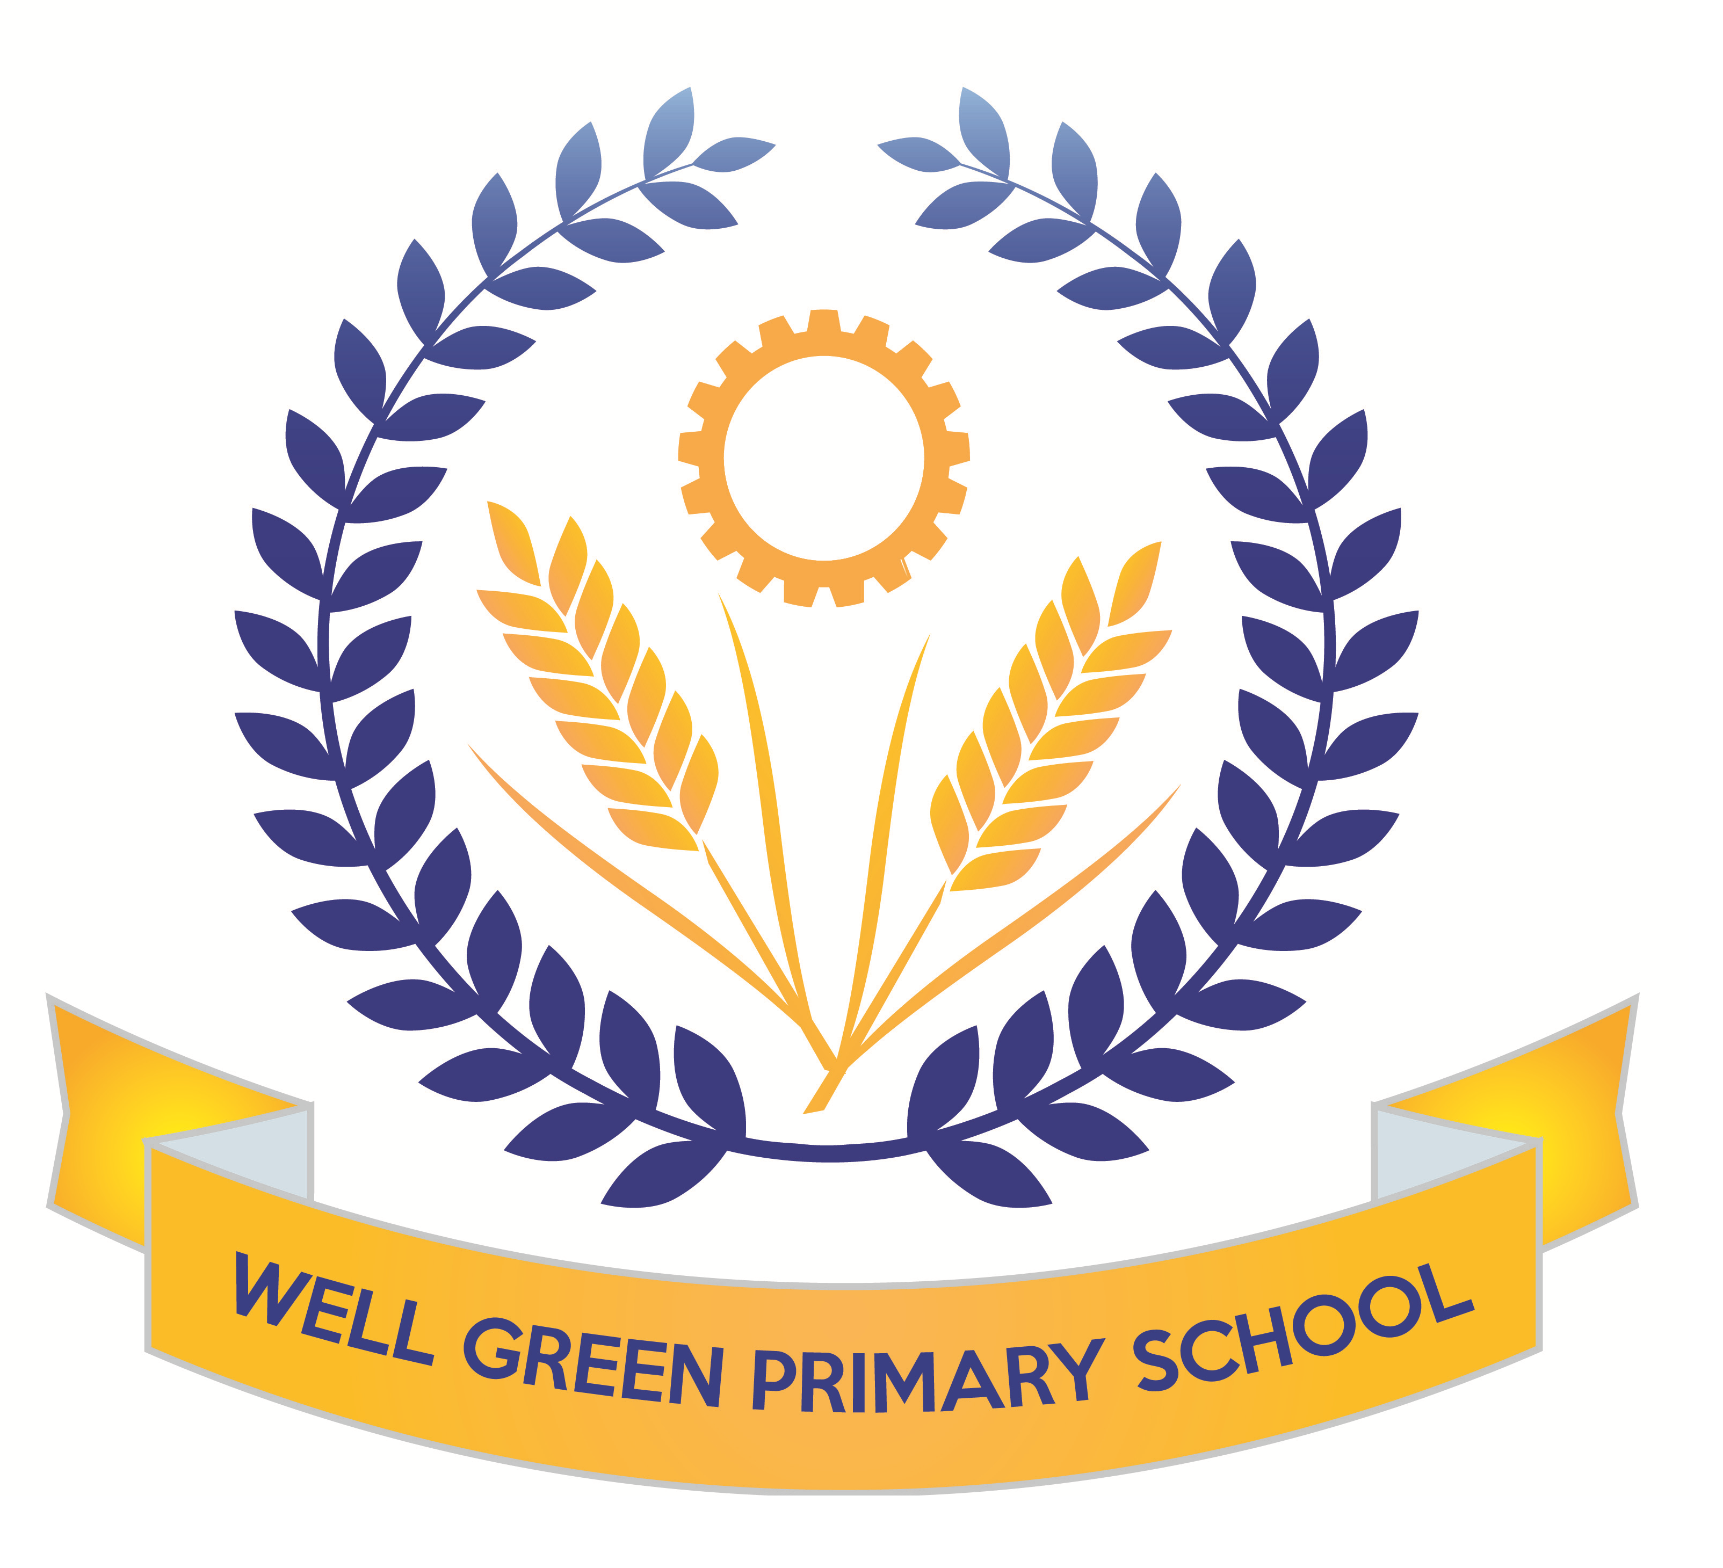

Well Green Nursery Autumn 1 2017

Welcome to nursery! We hope you have all had a great holiday. This half term we will be supporting the children in…
Personal, Social and Emotional Development | - Separating from parent/ carer with support and encouragement  - Show confidence in asking adults for help.  - Beginning to accept the needs of others and can  - Taking turns and sharing resources
Communication and Language | - Understanding and responding to simple questions  - Following directions  - Responding to simple instructions, e.g. to get or put away an object.
Physical Development | - Beginning to use appropriate to hold writing tools  - Drawing simple shapes such as circles and lines.  - Using one-handed tools and equipment, e.g. makes snips in paper
Literacy | - Sharing favourite stories, rhymes, songs, poems or jingles.  - Enjoying rhyming and rhythmic activities.  - Recognising rhythm in spoken words.  - Giving meaning to marks as they draw and paint.
Understanding the World | - Imitating everyday actions and events from own family and cultural background, e.g. making and drinking tea.  - Remembering and talking about significant events in their own experience.
Mathematics | - Noticing simple shapes and patterns in pictures.  - Using some number names and number language spontaneously.  - Reciting numbers aloud in order to 10.  - Showing an interest in numerals in the environment.
Expressive arts and Design | - Joining in singing favourite songs.  - Singing familiar songs.  - Exploring and learns how sounds can be changed.  - Engaging in imaginative role-play based on own first-hand experiences.

Your child must have a full change of clothes to be kept on their peg in nursery to save any upsets should they need to get changed.

Thank you for your continued support. The Nursery Staff.

