**Homework Task: famous scientists**

**Research the life and work of Margaret Hamilton. She was a software engineer, who worked for NASA in the 1960’s and made a massive contribution to the success of the Moon landing in 1969.**

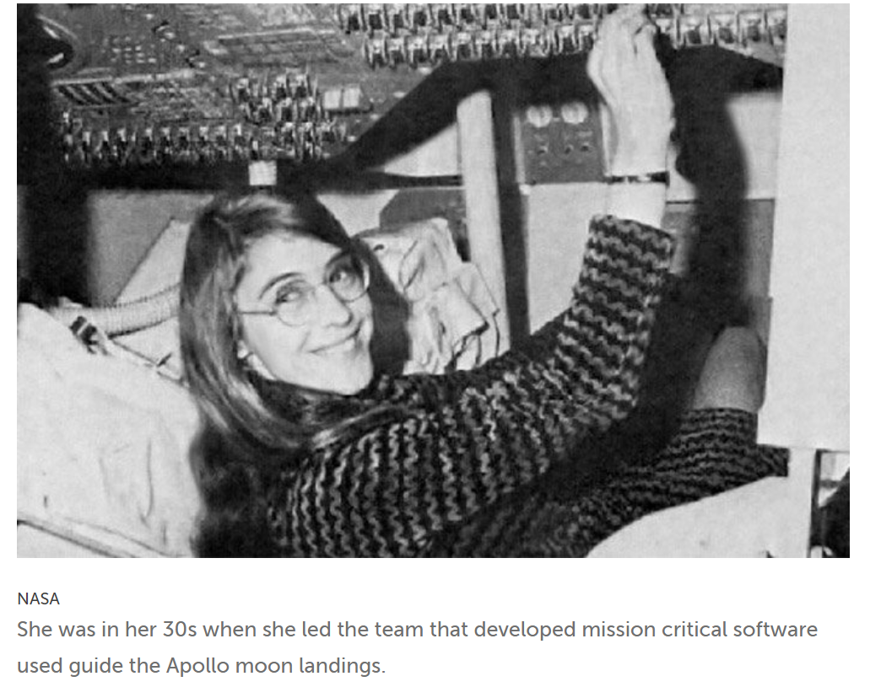

*I have uploaded a useful power point about Hamilton onto the website in our class page.*

*Present your work on the A4 paper provided. Make sure it is attractive, eye catching and above all informative. Return it by Monday 5th December*

**Remember to:**

* **outline her early life**
* **explain how she became a leading NASA engineer**
* **what was her contribution to the moon landing mission’s success**
* **explain why is she inspirational and a great role model to girls and women**