Friday 21st June
Communication and Language/Literacy
This week our focus texts have been ‘Slowly, Slowly Said the Sloth’ by Eric Carle and ‘Mog- The Forgetful Cat’ by Judith Kerr.
https://www.youtube.com/watch?v=PhiUlZ_CLqA

https://www.youtube.com/watch?v=yrDWaPqTzyM
The TIER 2 vocabulary this week has been ‘tranquil’ and ‘sloth’. We also chatted about what we can do if we have a bad dream.

Physical Development
We have practising for Sports Day. We have been mixing a cake mix which has built up our arm muscles.
We have practised yoga to improve our core strength.

Maths
We have been using a balance scale to make cakes. We have discussed ‘heavier’, ‘lighter’ and ‘the same’/’equal’. This practical method of looking at weight is the best way for your child to learn these concepts of measure.
Other Learning
In music we have been practising our Makaton signing song by Bob Marley, The Months of the Year song and nursery rhymes. In geography and science, we have learnt about some animals that live in South American rainforests.

HOMEWORK

Please read with your child every night for 5 minutes.
I have attached the recipe we used for balance cakes in class and put a link to a balance scale on Amazon, if you would like to have a go at home. This is a really good way of making cakes if you want to use the vocabulary ‘lighter’, ‘heavier’ and ‘equal’/ ‘the same’. https://www.amazon.co.uk/s?k=balance+scale+for+children&crid=176XD4FSNNK7M&sprefix=balance+scale+for+children%2Caps%2C88&ref=nb_sb_noss_2
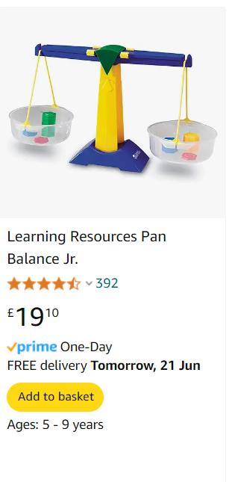

Thank you for your continued support
The Nursery Team
svancook@wellgreenprimary.co.uk

