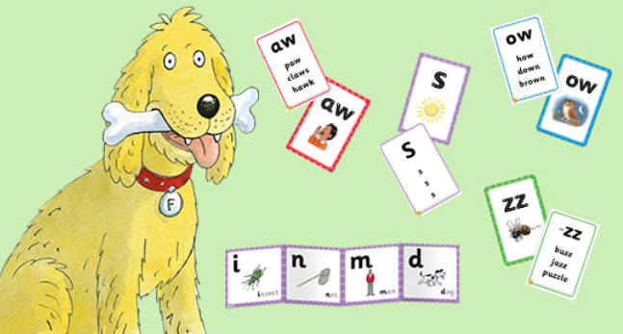

At Well Green Primary School we are committed to the delivery of excellence in the teaching of Phonics. We aim to develop each child so that they are able to read with fluency as well as develop a love of reading that will stay with our children all their lives.

We use the systematic and structured Phonics Programme Floppy’s Phonics. Floppy’s Phonics is in line with the Systematic Synthetic Phonics (SSP) teaching principles described in the ‘English programmes of study: key stages 1 and 2 – National curriculum in England’ which is statutory from September 2014.

The Floppy’s Phonics programme teaches the letter/s-sound correspondences of the English alphabetic code explicitly and comprehensively for reading and spelling. It includes the characters of Floppy the dog, Biff, Chip and Kipper and their family and friends, which engages children fully for the phonics teaching & learning, vocabulary enrichment and language comprehension.

Initially children's listening skills are developed through the use of music, environmental sounds and rhyme. During their journey through the Early Years Foundation Stage and Key Stage 1 they are taught the 44 phonemes (sounds) that make up all the sounds required for reading and spelling. These phonemes include those made by just one letter 'b as in bed' and those that are made by two 'ai as in rain or three letters 'igh as in high'.

Children are taught the key skills of blending sounds together for reading and segmenting (breaking up) words for spelling.

As the children grow in confidence and experience, they are introduced to alternative ways of representing the same sound, eg 'ee' can be represented as 'ee, as in bee', 'ea as in tea', 'e-e as in theme' and 'e as in we'. They also learn when to apply simple spelling rules and use verbs in the correct tense.

We ensure that our teaching of phonics is rigorous, structured and enjoyable. In Reception to Year 2, children have discrete, daily phonics sessions where they are introduced to new phonemes, explore, practise and revise previous learning and have plenty of opportunities to apply the knowledge they have.

We use a range of multisensory strategies to enthuse and engage the children, including the use of interactive whiteboards, magnetic letters, grapheme tiles, speaking and listening, and practical activities. Children work with pace and are encouraged to apply their knowledge across the whole curriculum.